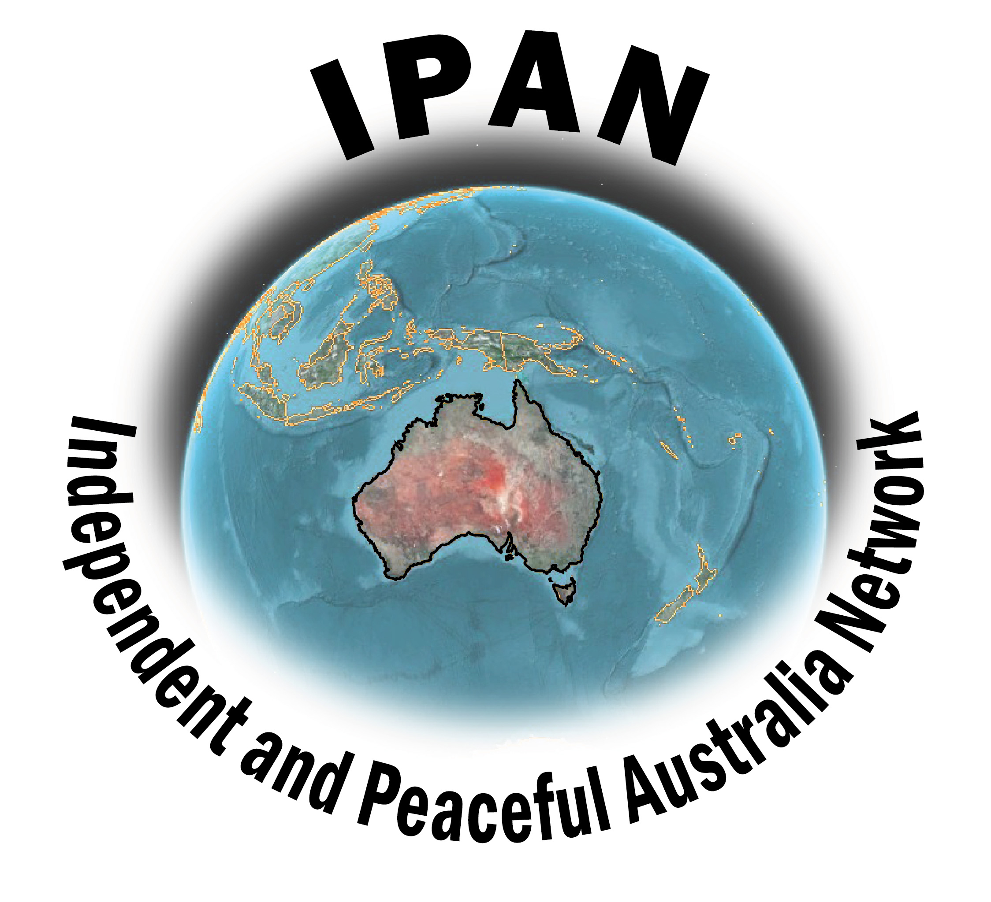
Independent and Peaceful Australia Network
Application for Membership

Membership of IPAN is open to all organisations who agree with our four aims, namely:
- Promote an independent Australian foreign policy that builds peace and nonviolent resolutions of conflict in our region;
- Oppose the establishment of foreign military bases, and the deployment of foreign troops and military hardware in Australia and the Asia-Pacific;
- Provide information analysis and opportunities for NGOs, unions, churches and community groups to participate in decision-making on Australia’s peace and security options;
- Build links with peoples and organisations in the Asia-Pacific campaigning for peace and against military bases and troops in the region.
Associate membership is also open to any person who agrees with these four aims.
Membership fee ranges from $20 for individuals and small organisations to $100 for large organisations.

Name: ..............................................................................................................................

Address:...........................................................................................................................

...........................................................................................................................

Email: .............................................................................................................................

Contact Person: ..............................................................................................................

Fee: ............................................ Organisational member

............................................. Individual Associate member
IPAN is a National Network that exists to advocate for an independent and peaceful Australia, free of foreign military bases, and other interventions by foreign Governments, corporations, or vested interests, that seek to exert undue influence in shaping Australia's foreign and defence policies in a manner that diminishes Australia's sovereignty.

Membership fee: $20: Small organisation.
$50 Medium organisation
$100 Large organisation
$20: Individual Associate
Please return to:
Independent and Peaceful Australia Network
PO Box 573, Coorparoo, Qld 4151
email: Ipan.australia@gmail.com
website: www.ipan.org.au
Direct Deposit (Reference your name!)to:
BSB: 814 282
Account: 5054 6137

