Keeping Australia out of U.S. wars
Friday, 5th July, 6.30pm
Hunter Union Building, 3rd Floor, Devonshire Lane, Newcastle
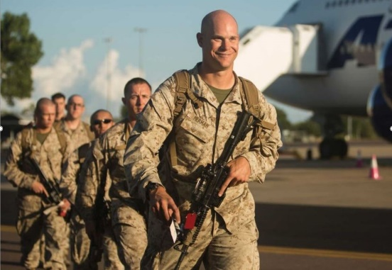
“Do the US Marines in Darwin pose a risk to our peace and security?”
Dr Anthony Ashbolt, Senior Lecturer, History and Politics, University of Wollongong, long time peace activist
Peace and Justice is Union Business
Arthur Rorris, Secretary South Coast Labour Council, long time peace activist and activist for worker’s rights
Why the U.S. marines in Darwin must be “given the boot” !
Launch of IPAN National Petition to oust the U.S. marines from Darwin
Nick Deane, NSW Rep on IPAN National Co-ordinating Committee, long time peace activist and secretary of Marrickville Peace Group
And plenty of opportunity for questions and comments
Organised by IPAN (Independent and Peaceful Australia Network (Queries: Bevan Ramsden 0418697528)
Largest contingent of US Marines, yet, arrives in Darwin to train and prepare with Australian Forces for a war against China
The first of this year’s 2,500 US Marines, the largest contingent yet, have arrived in Darwin for training and exercises.
Roughly the size of a Marine Expeditionary Unit, or MEU, it’s the largest deployment by Marines to Australia under the Force Posture Agreement signed in 2014 between the US and Australian Governments.
One of the major war exercises they will undertake with the Australian Defence Forces is Talisman Sabre, from 11th to 24th July, 2019. It will be based on and off the coast of Queensland, in particular Shoalwater Bay, Stanage Bay and the Great Barrier Reef.
In the past it has been difficult to determine the purpose of this exercise from the Defence Minister but this year, in an environmental report done by the ADF prior to this exercise, a diagram, shown below, was printed showing the concept behind the Talisman Sabre war exercises this year.

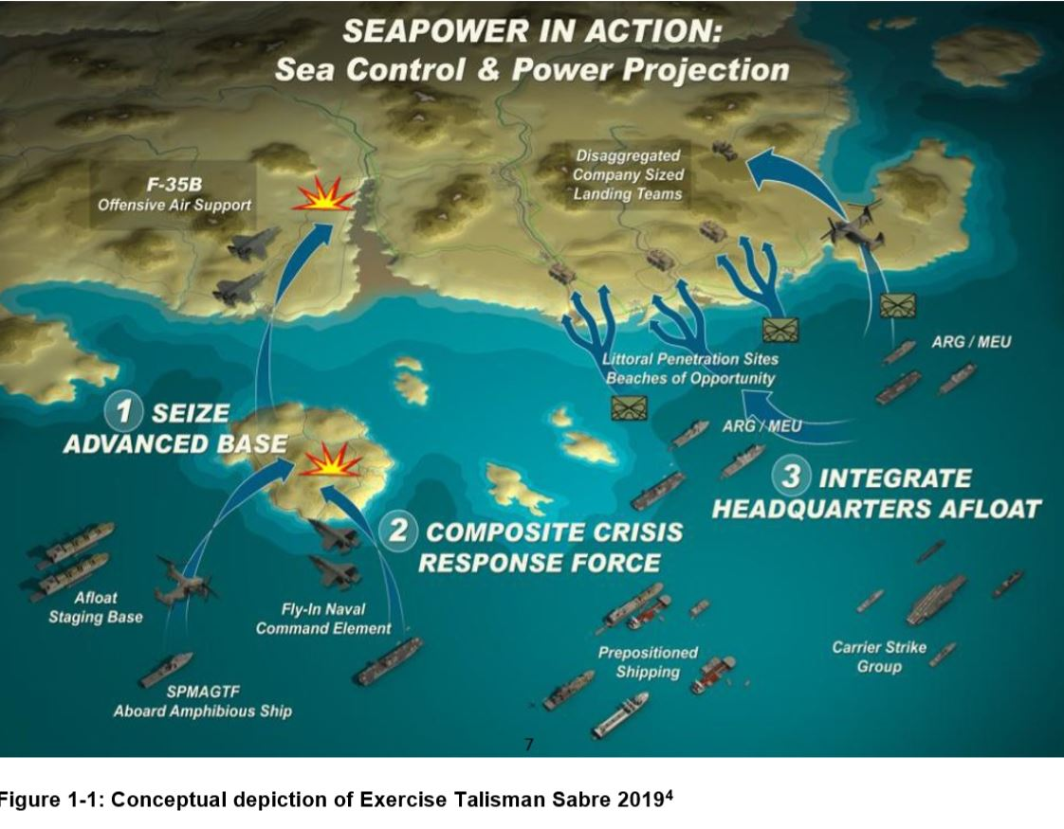

The diagram shows, bottom left, the SPMAGTF (Special marines air-ground task force) is carried by a ship with amphibious landing gear and transported to an island, which they seize and on which they set up an advanced base for a composite crisis response force. From this island base, attacks are made on a mainland. This is repeated with many islands and constitutes a new US Marines battle-field concept of dispersed island forces which it is claimed will make it difficult for China to counter. Recently the US Marines carried out an island capture practice war exercise of le Shima, an island off the coast of Okinawa.
The Australian naval ships, HMAS Adelaide and Canberra have been modified to support amphibious landing gear and in recent exercises US marine have been imbedded on these Australian naval ships.
It has become clear that the US is embroiling Australia in its preparation for war with China and that Talisman Sabre is a practice exercise for such a scenario.
(Excerpt from IPAN’s May 2019 edition of Voice)

